**Website** [**www.exampleweb.com**](http://www.exampleweb.com)



**PHONE**

**0307-1990167**

**Email**

**danishjajja@gmail.**

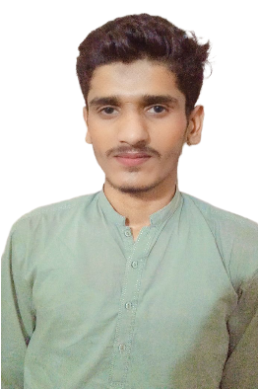

Danish jajja

Developer

A good developer can serve his his country by creating beneficial apps

**SKILLS** **CAD**

**development**

programming

**Collaboration**

**Creativity**

**EDUCATION** **BACKGROUND**

Matric from govt higher secondry school 123.6/r

**Inter from camery college faqir wali**

**Now I have joined agriculture universiry Faisalabad**

**WORK** **HISTORY**

work in inter part

**2019-2021**

**2021 2023**

**05/2021** **to** **Current**

**LANGUAGES**

**Urdu - Mother Language**

**•** **Freelance Work or Internships**

**•** **Specialization and Advancement**

**• solve a lot of problams**

**• Career Progression**

**English – Advanced Level**

**German - Advanced level**

JUNIOR EDITOR **02/2019** **to** **03/2022**

**AWARDS**

**I have no award in my profession.**

**•** **Supporting senior editors in various aspects of the editing process, such as media organization, rough assembly, or basic editing tasks.** **•** **Assisting in managing project assets, including organizing and labeling media files, graphics, sound effects, and music tracks for efficient access and usage.**

**• Assisting with audio editing tasks, such as syncing audio with video, adjusting volume levels, removing background noise, and incorporating music or sound effects.**

programming Summer Intern **14/2018** **to** **03/2023**

**HOBBIES**

**Books Reding**

**•** **Assisting with development Projects.**

**•** **create expensive software.**

**Cricket**

**Travel**

**Running**

**Animals**

**•** **Basic Effects and Transitions.**

**•** **Media Organization.**

**Photography**